

American International University-Bangladesh (AIUB)  
**Department of Computer Science  
Faculty of Science & Technology (FST)**

**PROJECT TITLE**

A Software Engineering Project Submitted

By

|  |  |  |  |  |
| --- | --- | --- | --- | --- |
| **Semester: Spring 22-23** | | **Section: B** | **Group Number:** | |
| SN | Student Name | Student ID | Contribution (CO1+CO2) | Individual Marks |
| 01 | Md Mehedi Hasan | 18-38925-3 | 17.5% |  |
| 02 | Jariatun Islam | 21-44458-1 | 20% |  |
| 02 | Arnab Bishakh Sarker | 21-44464-1 | 20% |  |
| 03 | Zobayer Alam | 21-44487-1 | 25% |  |
| 04 | Mohammad Nur | 21-44540-1 | 17.5% |  |

The project will be Evaluated for the following Course Outcomes

|  |  |  |
| --- | --- | --- |
| CO1: *Analyze* the impact of software engineering models over various context of software development to assess societal, health, safety, legal and cultural issues. | Total Marks | |
|  | |
| Project Background Analysis and feasibility (needs, goal, benefits, etc.) | [5 Marks] |  |
| Analysis the impact of societal, health, safety, legal and cultural issues | [5Marks] |  |
| Review of existing Studies and Relevant Example | [5Marks] |  |
| CO2: *Explain* appropriate software engineering model, project management roles and their skills in the context of professional engineering practice and solutions to complex engineering problems in a software development environment. | Total Marks | |
|  | |
| Appropriate Process Model Selection and Argumentation with Evidence | [5Marks] |  |
| Evidence of Argumentation regarding process model selection | [5Marks] |  |
| Submission, Defense, Completeness, Spelling, grammar and Organization of the Project report | [5Marks] |  |

Description of Student’s Contribution in the Project work

|  |
| --- |
| Student Name: Md Mehedi Hasan  Student ID: 18-38925-3  Contribution in Percentage (%): 17.5%  Contribution in the Project:   * Project Proposal * Functional Requirements * Activity Diagram   ___________________  Signature of the Student |
| Student Name: Jariatun Islam  Student ID: 21-44458-1  Contribution in Percentage (%): 20%  Contribution in the Project:   * Project Proposal * Functional Requirements * Sequence Diagram * Process Model   ___________________  Signature of the Student |
| Student Name: Arnab Bishakh Sarker  Student ID: 21-44464-1  Contribution in Percentage (%): 20%  Contribution in the Project:   * Project Proposal * Functional Requirements * Use Case Diagram * Class Diagram   ___________________  Signature of the Student |
| Student Name: Zobayer Alam  Student ID: 21-44487-1  Contribution in Percentage (%): 25%  Contribution in the Project:   * Project Proposal * Functional Requirements * Class Diagram * Activity Diagram * Process Model   ___________________  Signature of the Student |
| Student Name: Mohammad Nur  Student ID: 21-44540-1  Contribution in Percentage (%): 17.5%  Contribution in the Project:   * Project Proposal * Functional Requirements * Class Diagram   ___________________  Signature of the Student |

## Rubric for Project Assessment (CO1)

|  |  |  |  |  |  |
| --- | --- | --- | --- | --- | --- |
| Marking Criteria | Marks Distribution (Maximum 3X5=15) | | | | Acquired Marks |
| **Inadequate (1-2)** | **Satisfactory (3)** | **Good (4)** | **Excellent (5)** |
|  |  |  |  |  |  |
| Background  Analysis | No background information regarding the project is  given; project goals and benefits are  missing. | Insufficient background information is given; project goals and benefits are  poorly stated | Sufficient background information is given; the purpose and goals of the project are explained. | Thorough and relevant background information  is given; project goals are clear and easy to identify. |  |
| Analysis the impact of societal, health, safety, legal and cultural issues | Student vaguely discuss the impact of societal, health, safety, legal and cultural issues in their project | Student provided with partial relevance to the impact of societal, health, safety, legal and cultural issues in their project | Student fairly provided the analysis to the impact of societal, health, safety, legal and cultural issues in their project | Student comprehensively provided the analysis to the impact of societal, health, safety, legal and cultural issues in their project |  |
| Existing Studies and Relevant Example | Ambiguous representative example. | Partially identify / indicate towards real-life example. | Real-life example is fairly connected towards the definition. | Comprehensively defend with real life example. |  |
| Acquired Marks: | | | | |  |
| CO Pass / Fail: | | | | |  |

## Rubric for Project Assessment (CO2)

|  |  |  |  |  |  |
| --- | --- | --- | --- | --- | --- |
| Criteria | Marks distribution (Max 3X5= 15) | | | | Acquired  Marks |
| **Inadequate (1-2)** | **Satisfactory (3)** | **Good (4)** | **Excellent (5)** |
| Argumentation of Model selection with Evidence of Argumentation | Does not articulate a position or argument of choosing appropriate model. Does not present any evidence to support the arguments for the choice of the model | Articulates a position or argument for choosing models that is unfocused or ambiguous. Presents incomplete/vague evidence to support argument for model choice | Articulates a position or argument of choosing models that is limited in scope. Does not present enough evidence to support the argument for the choice of the model | Clearly articulates a position or argument for the choosing software engineering models. Presents sufficient amount of evidence to support argument for the model selection |  |
| Role identification and Responsibility Allocation | The project has poor project management plans for identifying roles and assigning the responsibilities | Identify few roles in the project management where some of the roles are left alone with any project responsibilities | Identify most of the roles in the project management and assign their responsibilities | Well planned project with proper role identification and responsibility allocation in the project management activities |  |
| Submission, Completeness, Spelling, grammar and Organization of the Project report | Project report is not complete and Several errors in spelling and grammar. Present a Confusing organization of concepts, supporting  arguments, and  real-life example.  Sentences rambling, and details are repeated. | Some errors in spelling and grammar. Some problems  of organizing the answer in a logical order of defining,  elaborating, and providing real-life examples. | Few errors in spelling and grammar. Presents most of the details in a logical flow of  organization in  definition,  details, and  example. | Project report is complete and No errors in spelling and grammar. Consistently  presents a logical  and effective  organization of definition,  details, and real-life example of  the topic. |  |
| Acquired marks: | | | | |  |
| CO Pass / Fail: | | | | |  |

**Project Proposal**

# Background

Dhaka metropolitan area is facing many problems most impacting is greenery & unemployment. Our system will try to implement a sustainable Dhaka city by creating greenery on rooftops & offering assistance by training the unemployed but eligible people.

# Solutions

1. The main objective of this project is to help the DCC residents implement a self-sustaining rooftop garden. That’ll increase the greenery in Dhaka city which is declining day by day. With added features like calling assistance for household tasks like water, electricity, sewage, gas etc.
2. Getting all the necessary assistance to implement a rooftop garden & maintaining it will be the focus of our system. This will ensure a little bit of greenery in the harsh concrete world. Our system will also lend out expensive & specialized machineries for a fraction of cost as a value-added service.
3. Dhaka Bangladesh govt has established youth training centers which gives vocational training. Every year the pass out rate of these vocational centers are very high, but employment rate is very low. So, to utilize their training properly govt can appoint them to a particular area as a certified assistant for a particular household work. This will ensure the proper use of their training & will make them self-sufficient.
4. The main targeted user groups of our solutions systems are the people with empty & unutilized rooftops. Which will then be transformed to serve as a self-sustainable garden. As per DSCC, they’ll enjoy a tax rebate of 10% for gardening. Secondly, we will also utilize the unemployed trained youths to serve society in its various tasks.
5. The contribution of this project to the advancement of scientific results is very impactful, as this system aims to improve the natural imbalance created by mass urbanization. F. (Literature review on tree plantation).
6. The software “sheba.xyz” is well-known among the existing studies in the problem area. This program is mostly used to get a helping hand for many of our daily problems. However, it lacks the greenery plan which we’ll do in our system.
7. “sheba.xyz” only focuses on assisting people with various tasks. But this proposed project will provide not only assistance but also a one-stop solution for gardening many essential renting out many useful accessories that comes at a high cost for a fraction of the amount and many more.

**Software Requirement Analysis**

1. **Software Login**

* The software will allow users to login with their given username & password.
* The credentials will be verified against the database records.
* If the login attempt is successful user will be transferred to user dashboard.
* If entered username or password doesn’t match user can perform a username or password recovery through his/her given email/phone number.

**Priority Level:** High.

**Pre-condition:** User must have a valid username & password.

1. **Software Signup**

* The software will allow new users to register.
* Users will enter their image [optional], name, address, email/phone number, desired username & password which will be then saved to a database.
* While registering a verification code will be sent out to the given email/phone number.

**Priority Level:** High.

**Pre-condition:** User must have a valid email/phone number for account verification.

1. **Product services search**

* The software will allow users to search through products or services that are available to purchase through the software.
* The searching system will be dynamic. Software will start to show matches as soon as user types something.
* Registered users will be able to use the search feature.

**Priority Level:** Medium.

**Pre-condition:** User must have a verified account.

1. **Garden registration**

* The software will allow new or existing users to register their own garden.
* Only the building owner can register under this option as the TIN & NID will be verified against NRB & EC sites.
* Registering for garden requires some basic info like Building owners name, Tax Identification Number, address, garden size, images of the garden [optional], email/phone number.
* Registering their gardens requires physical verification. After registration a physical verification will be conducted by agents.
* The registration page will show some basic requirements to pass the garden registration. Ex. Garden size. Tree types etc.

**Priority Level:** High.

**Pre-condition:** User must be the owner of the building to register.

1. **Gardening Equipment** 
   * A variety of gardening items will be available through the software. Tools, fertilizer, seeds, etc.
   * The user will choose the equipment they want, and those items will be placed to their shopping cart.
   * They can place an order at the selected address by using the checkout process.
   * The products will be made available to them within a short period of time.

**Priority Level:** Medium.

**Pre-condition:** User must register for a garden.

1. **Hiring a Gardener**
   * The software will have a function that allows users to hire a gardener to assist them by performing physical labor tasks in their gardens.
   * Through the software, the user will request a gardener with a date and time slot.
   * A person at their location will be available at the requested time.

**Priority Level:** Medium.

**Pre-condition:** User must register for a garden.

1. **Solar Power Panel**
   * The software allows users to book solar panel through a registration system.
   * The system will automatically take the username and address of the users from the profile data, or the user can manually input those.
   * The system will ask for the rooftop area. Users can put their rooftop area in desired measurements.
   * The system will suggest an ideal size and power of solar panel for the specific rooftop.
   * Users also can upgrade the solar panel though the system will maintain a margin. This also goes for downgrade.
   * At bottom of the same page the system will show the expanses of the solar panel.
   * If user like to purchase the panel system will forward it to cart segment for the payment process.

**Priority Level:** Medium

**Pre-condition:** User must have to have a profile in the system.

1. **Garden feeds**
   * The software allows users to stay updated with other users through a feed system.
   * The system will allow users to post reels and short stories of garden.
   * The system will have a post reel function. Which will take the user to files and have an access permission to use the camera directly.
   * The system will allow a certain size file. If the user exceeds the limit, the system will notify with a message.
   * Users also can react to the feeds with two allowed reaction emoji.
   * The system will save a record to the database and every month it will pick 5 most reacted feeds.
   * The feeds segment will have another sub segment Tips & tricks.
   * It will take the user to another page which will have a list of categories based on basic information about gardening.
   * The user also can post short tutorial tips and tricks videos of their own.
   * The system will have a post function which will take files from the users.
   * User must have to put a category from the listed options so that the system can categorize the content.
   * Users can see the content of other users and specialist.

**Priority Level:** Medium

**Pre-condition:** User must have to have a profile in the system.

1. **Subsidiary panel (tax reduction/utility bill reduction):**
   * This function calculates and finds out the tax benefit they can gain if they register their garden.
   * This function calculates and finds out the utility bill reduction they can obtain after they become a part.
   * A guest or user needs to provide their location, the area of their garden, the area of the whole rooftop, the area, and the number of solar panels.
   * Total solar panel area is found out by multiplying the solar panel area and the number of solar panels.
   * Fixed rates for a different range of areas of the garden and total solar panel area are pre-determined.
   * Using the rates, the overall benefit is shown.

**Priority Level:** High

**Pre-condition:** User must have to have a profile in the system.

1. **Expert opinion:** 
   * This function allows rooftop planners, who are authorized by the company, to provide expert suggestions.
   * They provide a customized plan for each rooftop depending on the location, size, and condition of the rooftop.
   * They can design a new garden or modify an existing one for better use of the limited area.
   * They can help to solve existing problems with plants and solar panels and provide maintenance tips.
   * They can also provide a cost-efficient and easy way of maintaining such gardens.
   * A user has two options, he can make a video call, or can request a house tour.
   * Each session is pre-paid and has a fixed rate depending on the type and duration of the session.

**Priority Level:** Medium.

**Pre-condition:** User must have to have a profile in the system.

1. **Notification:**
   * This function sends notifications on their status of registration.
   * Users get notifications when they need to pay attention to certain functions such as providing required information.
   * Users receive the booking remainders.
   * Users receive suggestions for using other functions.
   * Send notifications about special events or discounts going on the platform.

**Priority Level:** Medium.

**Pre-condition:** User must sign in.

1. **Donation**
   * The software will offer a donation opportunity.
   * Users can donate food, clothing, and money to help the needy and poor.
   * If a user requests a donation, our volunteers will collect those donations every week.
   * The user may also make a donation using one of several online payment methods.

**Priority Level:** Low.

**Pre-condition:** User must have a verified account.

1. **Software Add to Cart /Checkout**

* The software should allow users to add any kind of product which are available on the shop page.
* From the cart, the users should delete products from the cart and add products that the user want.
* The software should display unit price, sub-total, and total.
* The user should confirm the order by checkout the page.
* On the checkout Page, the software should display which payment the user wants.
* After choosing the payment method, the software should confirm the order and mail it to the admin and the user.

**Priority Level:** Low.

**Pre-condition:** User must have a verified account.

1. **Software Service History**

* The software should allow the user to see every service that the user has taken.

**Priority Level:** Low.

**Pre-condition:** User must have a verified account.

1. **Software Feedback**

* The software should allow the users to give feedback on every operation.
* The software should allow this feature optional.

**Priority Level:** Low.

**Pre-condition:** User must have a verified account.

1. **Software help and customer service**

* The software should allow the users to message the help center.
* The software should allow the users to call the help center.

**Priority Level:** Low.

**Pre-condition:** User must have a verified account.

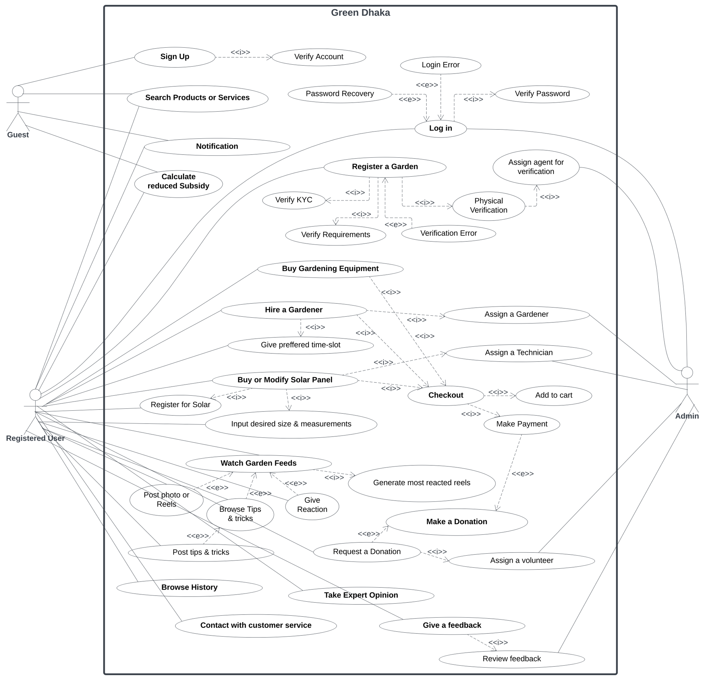**Use Case Diagram**

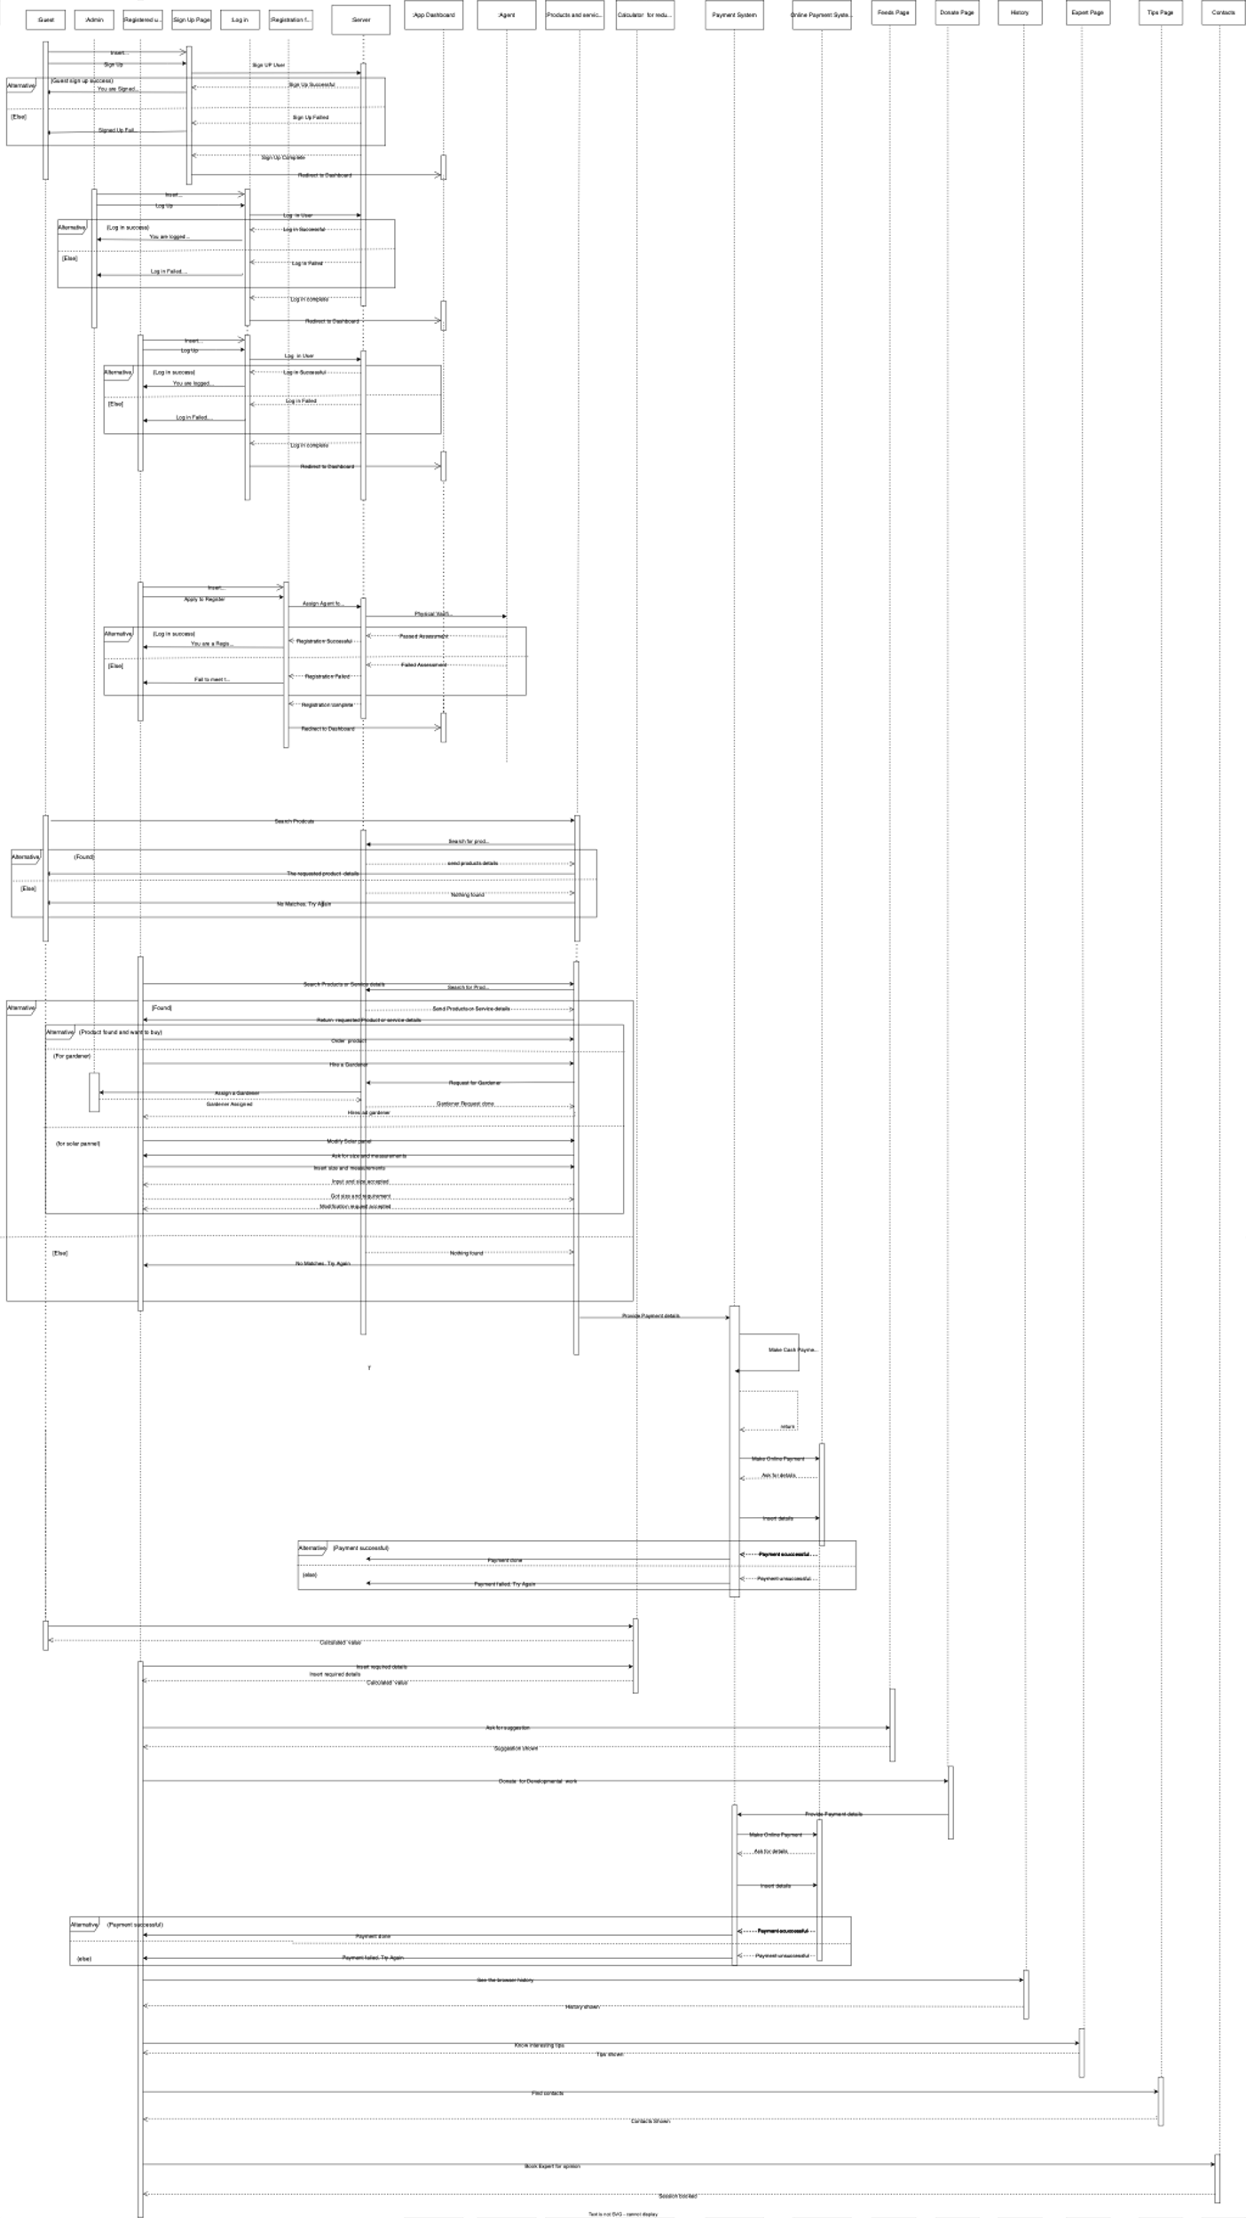**Sequence Diagram**

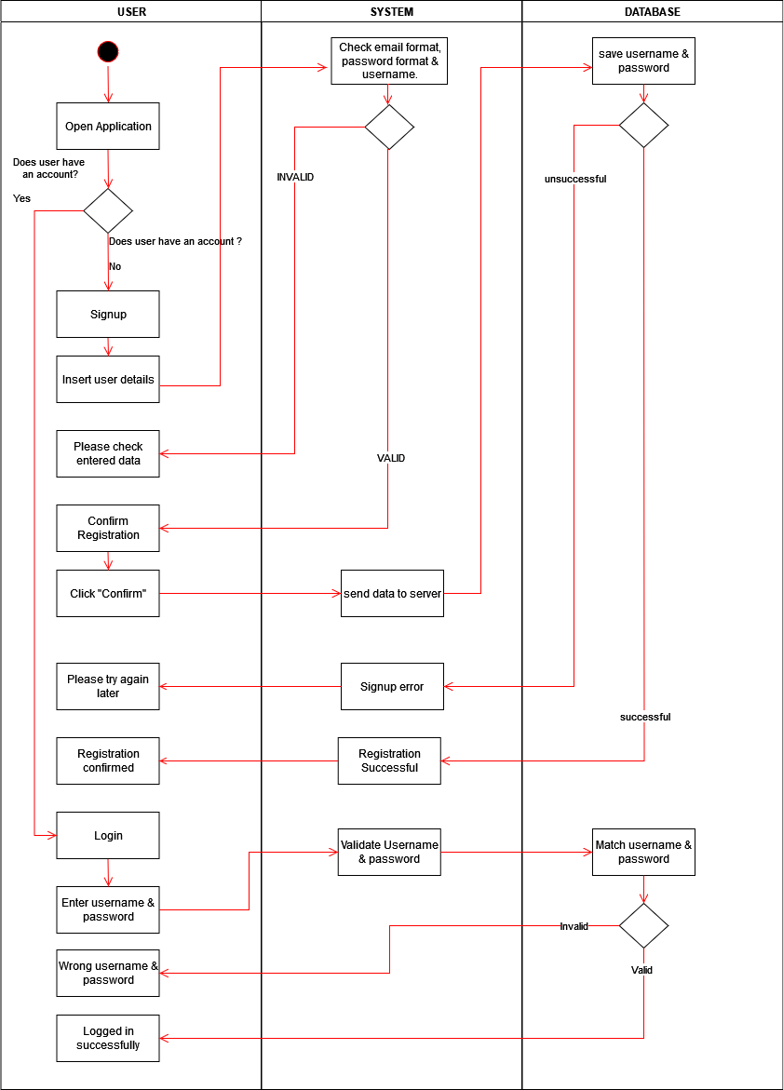**Activity Diagram**

**Signup**

**Garden**

**Search**

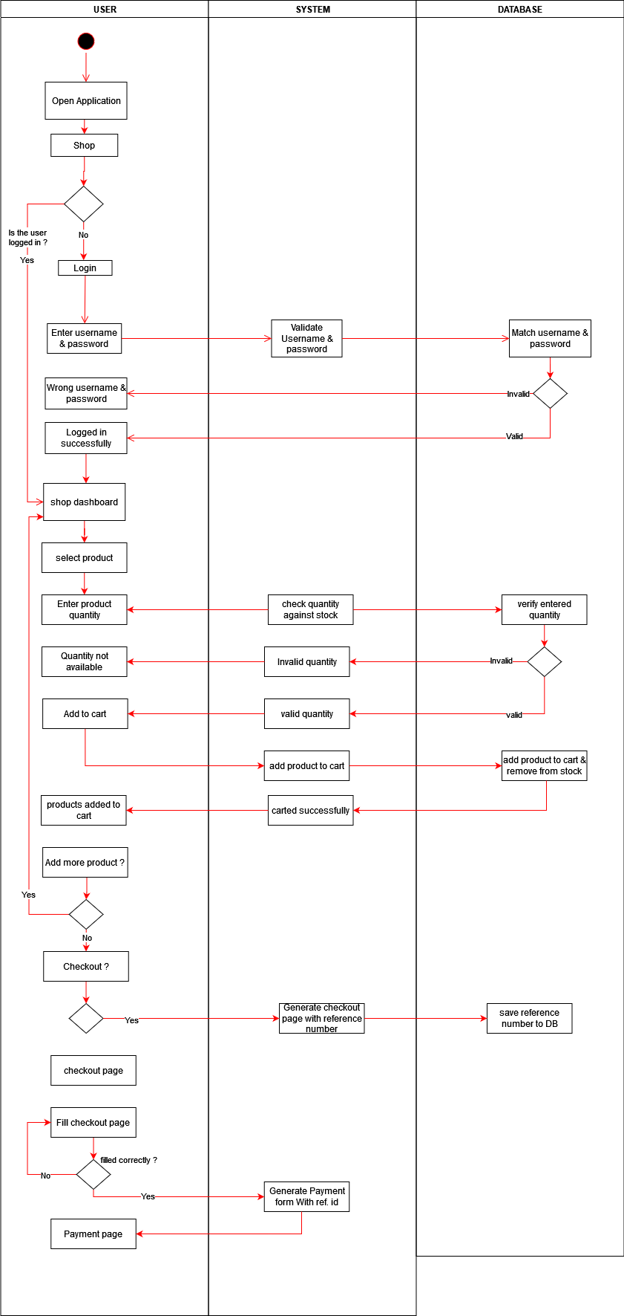

**Shop**

**Solar**

**Payment**

**Choosing the Process model for the project**

1. **Process model for the project.**

We have chosen Incremental prototype from iterative process model to effectively provide us with guidance to control & coordinate the task to achieve the final product and objectives as effectively as possible.

1. **Reason for choosing incremental model.**

Iterative process models are designed for repeating stages of the process. That is, they are iterative or cyclical in structure. The advantage of iterative processes is the ability to loop and revisit previous phases (and their activities) as part of the process. Each “loop back” is an iteration, hence the name “iterative process.” Iterations allow for client feedback to be incorporated within the process as being the norm, not the exception. Iterative process models are readily amenable to Agile practices, yet they also embody sequential portions reminiscent of linear process models. When a product is built and released in increments, it is an incremental prototype. In incremental prototyping a triage system is followed,

“Triaging” means assessing each of the system’s components and assigning a priority. Based on that priority, a product’s components are built iteratively in increments from “most important” to “least important.” In this way, incremental prototypes make use of the process philosophies behind iterative processes models. Priorities for a software product’s features are based on three categories: “must do,” “should do,” and what “could do.” Core features are assigned the highest priority—must do. In our project the most important feature is encouraging users to register their roof gardens & tax benefit. Additionally registering for solar panel will improve the condition of our city by reducing carbon emission because of higher usage of renewable energy. Another core feature is tax reduction calculator which will allow the use to know how much they can save with their contribution to our green project. All these features will be implemented & deployed in the first increment. In the second increment we will focus on the product & service part of the application. Customers can buy products at a reduced cost. They also can hire gardener & ask for expert advice. The other features are newsfeed for the users to post & react to them. They also can make donation, browse their history, ask for tips & also can contact for technical support.

1. **Comparison with other models.**

Waterfall model, Agile, and Incremental Prototype are three different process models used in software development. Here's a comparison of these models:

***Waterfall Model:*** The Waterfall model is a sequential approach to software development, where each stage of development follows the previous one. The development process proceeds in a linear fashion, with each stage being completed before the next one begins. The stages include requirements gathering, design, development, testing, and deployment.

**Disadvantages:** The Waterfall model is inflexible and does not allow for changes or modifications. Testing and debugging occur only after the completion of the development phase, which can be risky and expensive. The model may not be suitable for projects with evolving or unclear requirements.

***Agile Model:*** The Agile model is an iterative and incremental approach to software development, where each development cycle involves planning, design, development, testing, and delivery. The Agile model is designed to be flexible and adaptable, with a focus on collaboration and continuous improvement.

***Disadvantages:*** The Agile model requires a high degree of collaboration and communication between team members, which can be resource intensive. The model may not be suitable for large-scale projects or projects with strict deadlines. The model may not be suitable for projects with complex requirements.

# Justification

In summary, the Waterfall model is suitable for projects with well-defined requirements and fixed budgets or deadlines. The Agile model is suitable for projects with evolving or unclear requirements and a need for flexibility and adaptability. The Incremental Prototype model is suitable for projects with evolving or unclear requirements and a need for early testing and feedback.

**Roles**

* Project Manager: responsible for overall project planning, execution, and monitoring.
* Product Owner: responsible for defining the requirements and priorities for the product.
* Developers: responsible for coding and testing the software.
* Testers: responsible for testing the software to ensure that it meets the requirements and is free of bugs.
* UX/UI Designer: responsible for designing the user interface and ensuring that the software is easy to use and visually appealing.
* Technical Writers: responsible for creating documentation and user manuals